**MISSING FEATURES**

The eCommerce website's testing revealed significant gaps in key elements that need to be addressed to improve user experience and streamline administrative procedures. Addressing these gaps is crucial to meet evolving needs of administrators, consumers, and industry standards.

The following are some of the missing features found in the project under test:

1. Admin/Customer Logout Screen
2. Admin/Customer Profile Page
3. Separate Home/Welcome pages for Admin/Customer
4. View your cart (update/delete/add/edit)
5. Check out screen
6. Delete user button for <http://localhost:8080/admin/customers>screen
7. Search Option pane
8. Multiple categories, multiple panes
9. Side Bar Menu (Hamburger or breadcrumbs menu)
10. Payment Feature
11. Payment Options
12. Payment Methods (master card/PayPal)
13. Transaction screens
14. Order tracking for Customer/Admin
15. Help and Customer Support Screen
16. Privacy Policy
17. Contact Us Screen

**Description**

**Admin/Customer sign out Screen:**

The logout screen for eCommerce website is missing. Logging out is crucial for security and privacy, ensuring unauthorized access is prevented. The following is Amazon’s sign out screen.

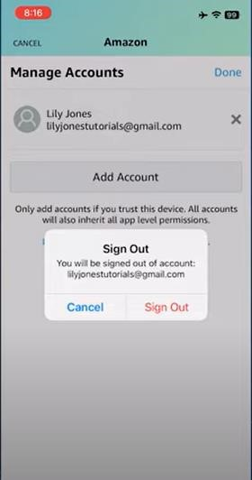

**Admin/Customer Profile Page:**

The profile page for eCommerce website is missing. It allows users to manage and update personal information, enhancing user experience and customization. The following is Amazon’s profile page.

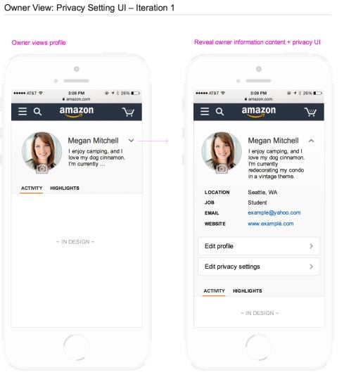

**Separate Home/Welcome pages for Admin/Customer:**

The welcome page for eCommerce website is missing. Tailoring the home/welcome page for different user roles streamlines access to relevant information. The following is Amazon’s welcome page.

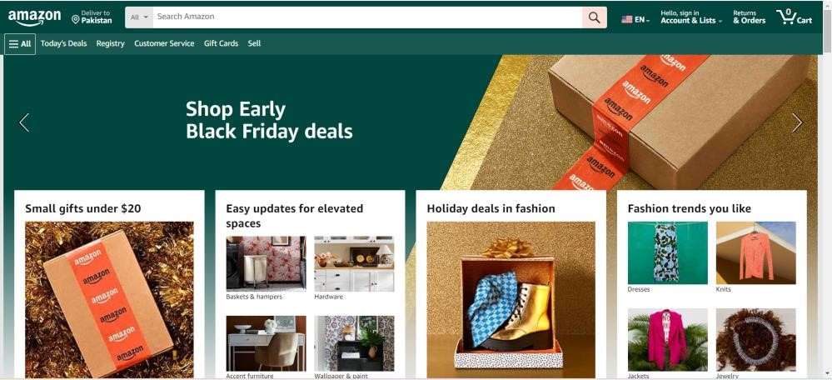

**View your cart (update/delete/add/edit):**

View cart option for eCommerce website is missing. Without this option users cannot efficiently modify their cart, leading to a less user-friendly and frustrating shopping experience. The following is Amazon’s cart.

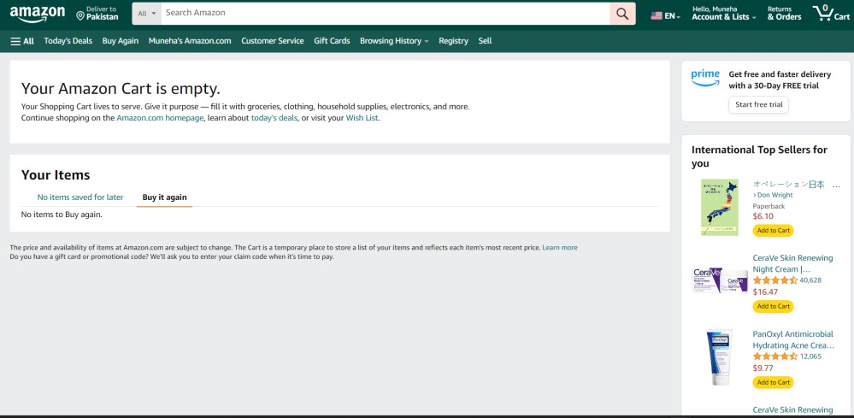

**Check out screen:**

Checkout screen for eCommerce website is missing. Without a proper checkout screen, users may abandon transactions, impacting revenue and user satisfaction. Following is Amazon’s checkout screen.

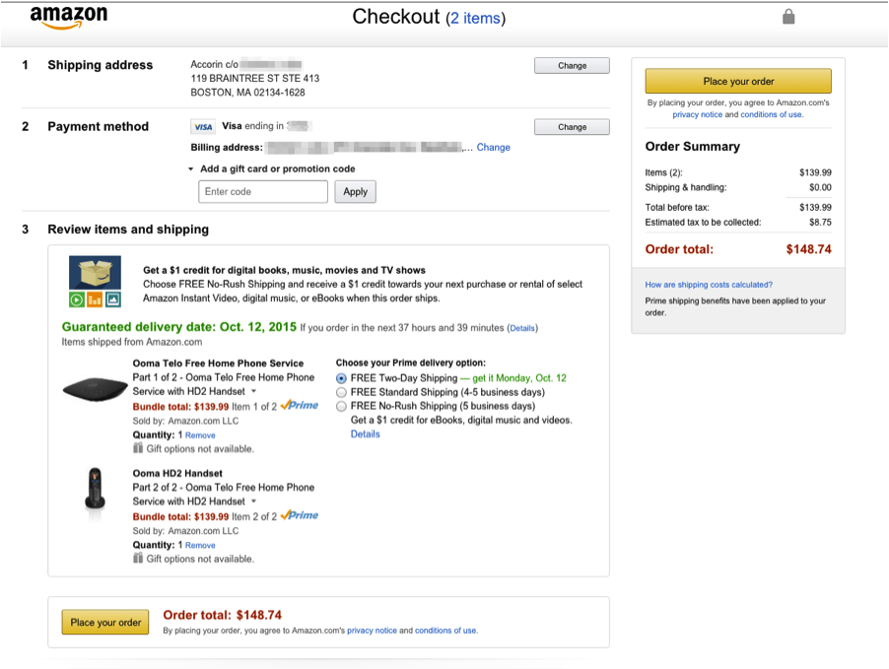

**Delete user button for** [**http://localhost:8080/admin/customers**](http://localhost:8080/admin/customers) **screen:**

Delete user option for eCommerce website is missing. Admins lack the ability to remove users easily, potentially leading to a cluttered and less secure user database. Following is Amazon’s eCommerce’s page with delete functionality missing.

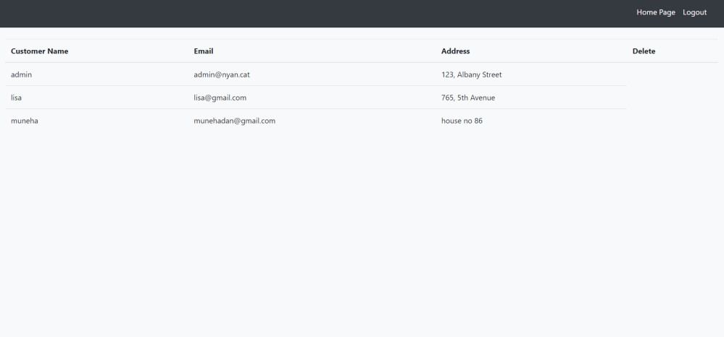

**Search Option pane:**

Search option for eCommerce website is missing. Users may struggle to find relevant information, leading to frustration and a less efficient user experience. Following is Amazon’s search pane.

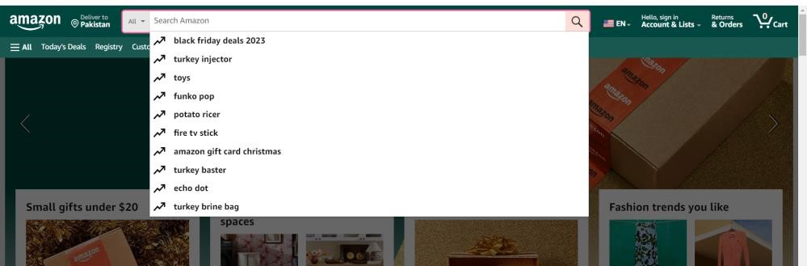

**Multiple categories, multiple panes:**

Categories feature in eCommerce website is missing. Lack of categorization may result in a cluttered interface, making it challenging for users to locate specific items. Following is Amazon’s page with categories.

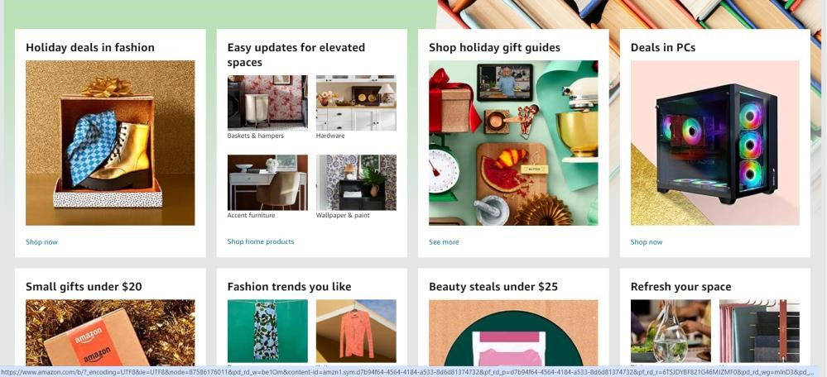

**Side Bar Menu (Hamburger or breadcrumbs menu):**

Side bar menu for eCommerce website is missing. Without a clear navigation menu, users may find it difficult to explore different sections of the application. Following is Amazon’s Side bar menu.

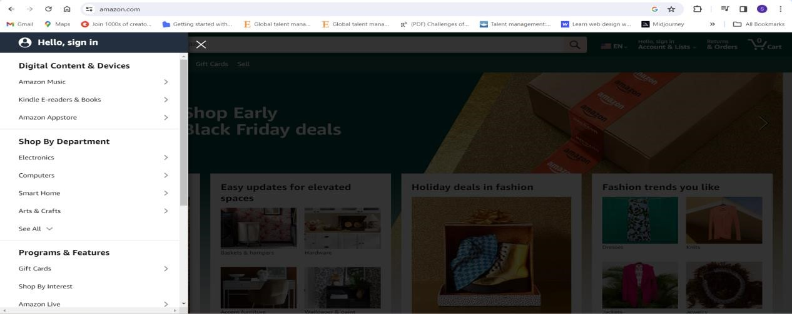

**Payment Options:**

Payment options feature for eCommerce website is missing. Limited payment options may deter potential customers who prefer alternative payment methods. Following is Amazon’s Payment options feature.

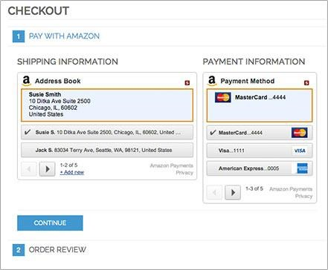

**Transaction screens:**

Transaction screen for eCommerce website is missing. Without transaction screens, users lack visibility into their past activities, potentially causing confusion or concern. Following is Amazon’s transaction screen.

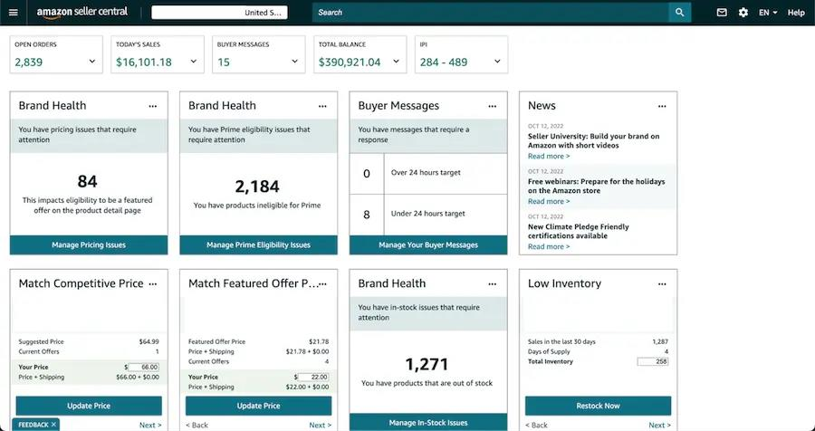

**Order tracking for Customer/Admin:**

Order tracking in eCommerce website is missing. Users cannot monitor the progress of their orders, leading to uncertainty and potential customer service inquiries. Following is Amazon’s order tracking screen.

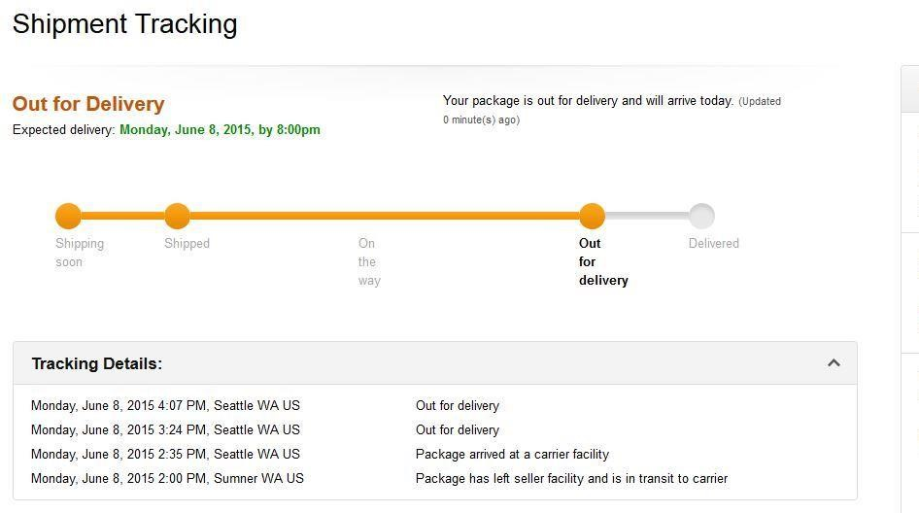

**Help and Customer Support Screen:**

Customer support on eCommerce website is missing. Users may struggle to find help or support, leading to frustration and a negative user experience. Following is Amazon’s Customer support screen.

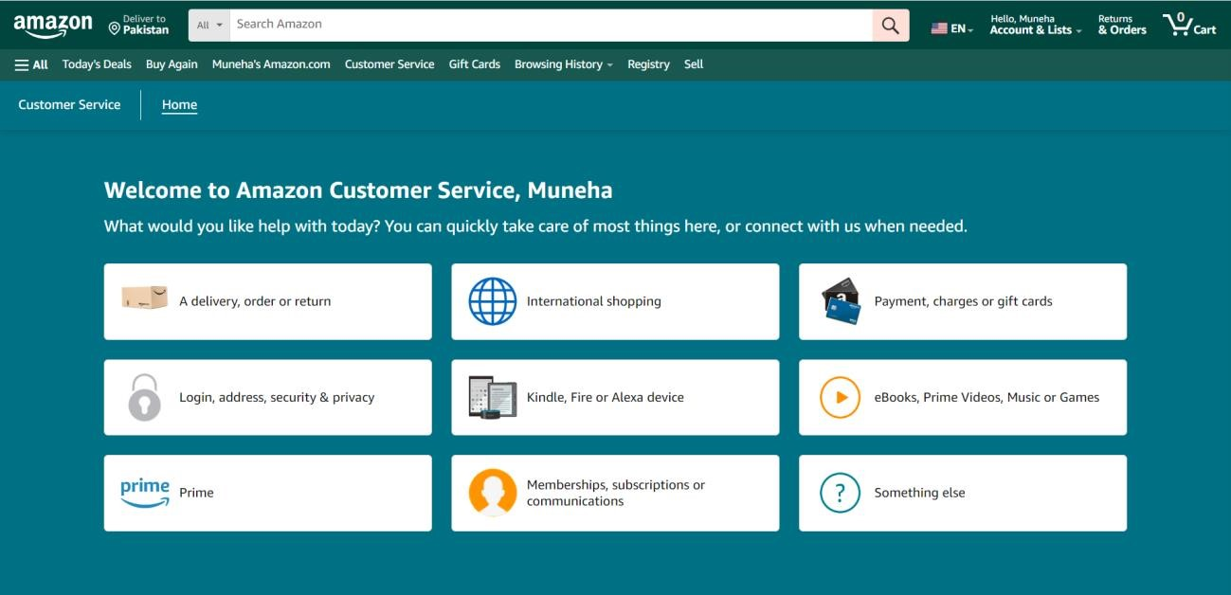

**Privacy Policy:**

Privacy policy for eCommerce website is missing. Lack of a privacy policy may erode user trust and could lead to concerns about data security. Following is Amazon’s Privacy policy.

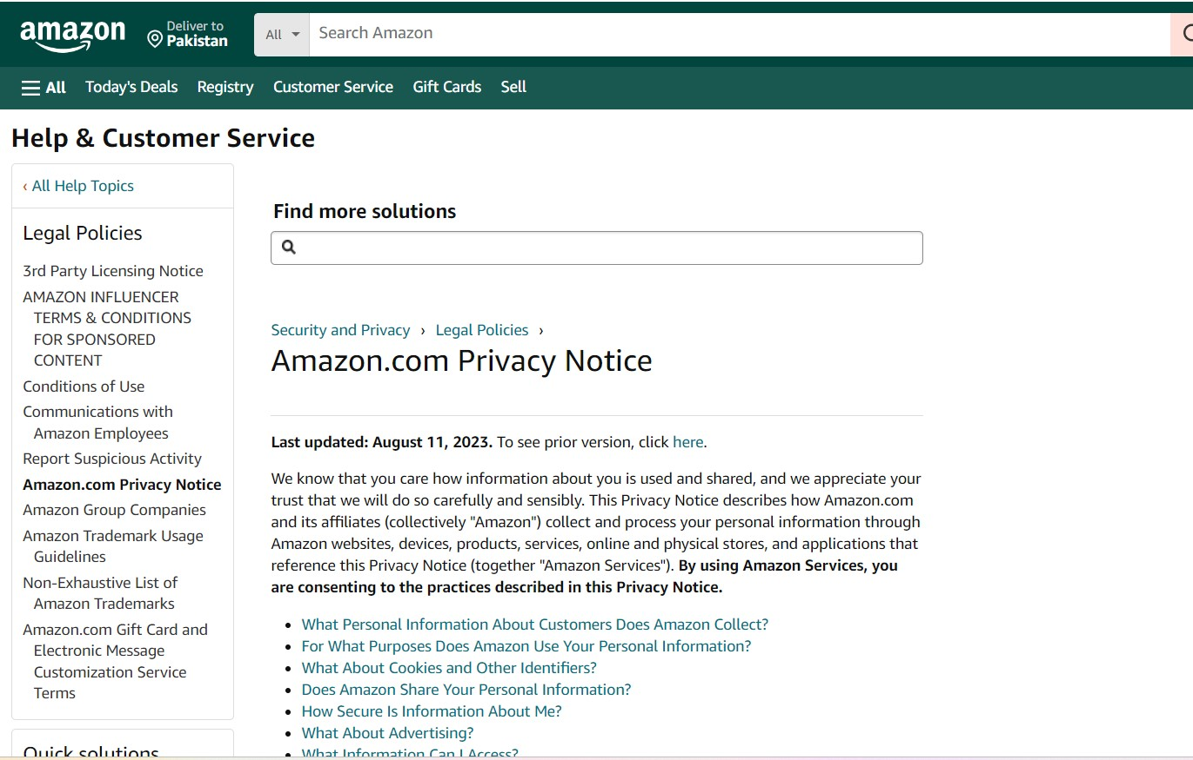

**Contact Us Screen:**

Contact us option for eCommerce website is missing. Without a contact option, users may feel isolated, and the application may miss valuable user input. Following is Amazon’s contact us screen.

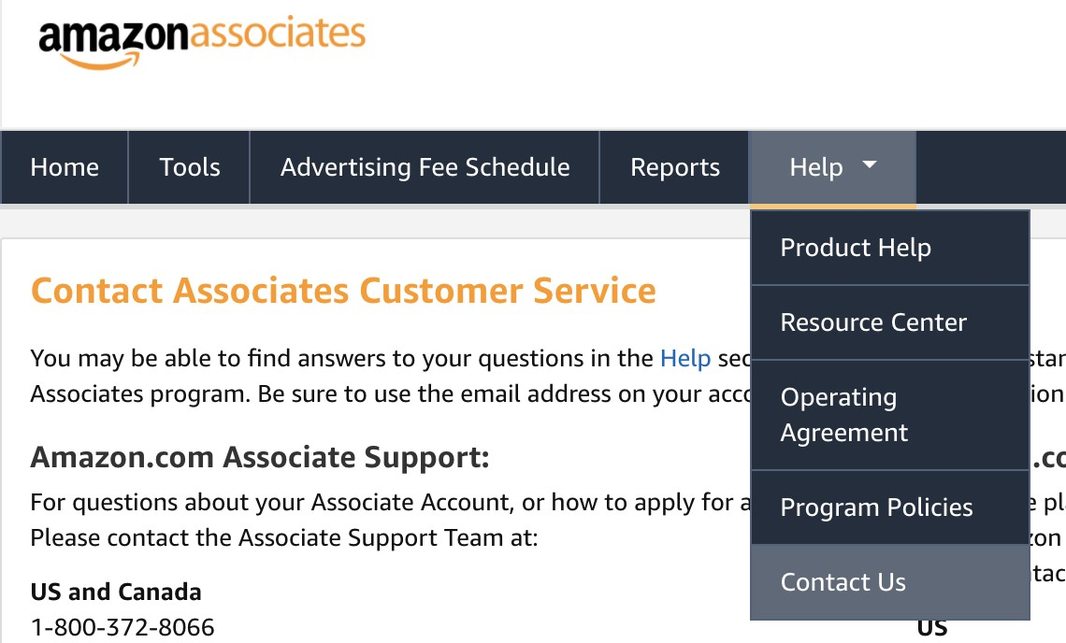

**Returns and Refunds Policy and options:**

Return and Refund Policy and option for eCommerce website is missing. Users may be hesitant to make purchases without a clear understanding of return and refund policies. Following is Amazon’s Return and Refund Policy and option.

